**Quantum Measurement Simulator**

**By: Lily, Kerwin, Steven and Daniela**

Richard Feyman believed that quantum simulators held the potential to emulate other quantum systems more efficiently than classical computers [1]. He envisaged that a quantum computer would have the capability to retain exponential data, making it an ideal tool for taking quantum measurements [2]. And so he speculated that a quantum measurement simulator was capable in theory to mimic a system of another [1]. Ten years later, it was demonstrated that a quantum computer could perform like a quantum simulator [2]. Ever since then, scientists have been intrigued by the possibilities that quantum simulators have to offer [2]. As Georgescu, M. & *et al* states, “By quantum simulator, we understand a controllable quantum system used to stimulate/emulate other quantum systems” [2]. Although quantum simulators are feasible, they are a challenging problem especially when large complicated systems are investigated [3]. Despite the level of difficulty, quantum simulators permit the study of less controllable or attainable systems [3]. Quantum simulation therefore has sparked the interest of various fields in science such as physics, chemistry and biology with applications in condensed-matter physics, high-energy physics, atomic physics and quantum chemistry [3].

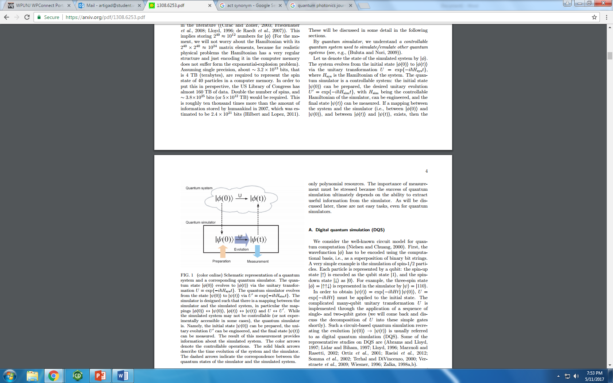

Figure 1

As seen in Figure 1 above, a schematic representation of the influence between a quantum simulator and a quantum system are shown. As indicated in the schematic above, the quantum system and quantum simulator evolve via the unitary transformation, U=exp{-ihHsyst} and U’=exp{-ihHsimt}, respectively. A mapping between the simulator and system are needed in order to be able to obtain a measurement from an uncontrollable system. These mappings take place among the initial state, unitary transformation and final state for both the simulator and the system. Once the initial state of the simulator is prepared and the unitary evolution has been engineered, the final state can be measured providing information about the simulated system [2].

The quantum measurement simulator states that any system can be chosen for measurement, no matter how complex the system may be [4]. This is feasible due to the quantum simulator capability in providing information on the system, only after a measurement has been made [2] [4]. Once a measurement has been made, the system that was formerly found in superposition will collapse into a particular state. The quantum measurement simulator is based on the Stern-Gerlach experiment, which studied the splitting of the Ag atom beam depending on their passage through two opposite magnetic poles. This experiment was able to effectively separate the system into unique quantum states only after measurement. When a measurement was taken on the Ag beam system and the splitting of the beam resulted according to the spin of the atom, it was found that angular momentum is quantized.

The Double-Slit experiment also serves as an important basis for the development of our quantum measurement simulator. This particular experiment explains quantum mechanics and our system as it relates to the Stern-Gerlach experiment. The experiment was used to test the behavior of marbles, light bulb waves from light, and electrons. For the experiment, two screens were used, one with a single slit in the middle, and the other with two slits, both with a blackboard behind them. When a machine randomly shoots marbles through the single slit, what is noticed is that a single line appears on the black board. When the same machine shoots the marbles through the screen with two slits, what is noticed is that there are two lines that appear on the black board behind the screen. Next, a light bulb is turned on in order to shine light through the single and double slit screens. Through the single slit screen, a single line pattern is observed on the blackboard. On the other hand, in the case of the double slit, there are alternating lines observed on the black board. The explanation for this is that the waves from the light were interfering with one another. As the light bulb shined the light through the slit in a wave pattern, the wave actually broke up into many different waves and interference lines were generated where the crests of the waves were intersecting with one another. When the crest of a wave and a trough of a wave meet up, they cancel each other out and do not leave a line on the blackboard. This is the reason attributed to the alternating interference lines on the blackboard.

Since electrons are of the same shape and only differ in the nature of their smaller size as compared to the marble, they were expected to show the same behavior and patterns as the marble. When the electrons were shot through the single slit, it showed a single line on the black board. When the electrons were shot through the double slit, it showed interference patterns. Physicist’s believed that the electrons were bouncing off of each other and causing interference lines so, they set the machine up to fire a single shot of each electron instead of a joined one. After conducting the test, the same interference lines were shown, so they believed that the electrons were splitting themselves up as they went through the left and right slit, and then bounced off one another once they went through and hence caused interference lines. They also believed that some electrons were only going through the left slit, some were only going through the right, and that some were not actually going through at all. Physicist’s said that the electrons were in superposition so they decided to use a machine that observed and measured how many electrons would split up, how many would not go through, how many would only goes through the left slit, and how many would only goes through the right slit. When observing the electron they noticed that the behavior had changed and the electrons were not giving off interference lines but instead they portrayed the two single lines, similar to the results from the marble. What was concluded was that by trying to measure or observe the electron, the electron had collapsed. When the electron was being observed, it behaved differently and the question is, why? The very act of measuring, or observing, which slit it went through meant that it actually went through one slit only, not both. The electron chose to act differently when it was being observed, as if it was aware that it was being watched. The observer collapsed the wavefunction, simply by observing. It is for these reasons, that the quantum world is so mysterious.

Different formulae were used in the construction of our quantum measurement simulator. We used the very important Time-Dependent Schrodinger equation since we have a function that changes over time. The TDSE shows how when given an initial wave function, one can predict the future behavior using Schrödinger's Equation. In classical mechanics for a particle moving in a 1-dimensional box, all that we need to know is the position and the momentum. In our simulator we had a particle that changes over time so we used the TDSE to determine where our particle is as time goes on. The TDSE equation plays the same role in quantum mechanics as Newton’s second law plays in classical mechanics.

In our system, we need to know the position of our particle first so we initialize a Probability distribution function that gives us a Gaussian curve. This curve lets us know the probability of finding our particle at a certain position. When a measurement is taken, it will be used in the TDSE to determine the state of the particle in future time.  In our system, the probability of our particle changes over time so in order to use the TDSE we need to update the wave function with respect to the time it is taking the measurement. Thus we introduce the Runge-Kutta third order (RK3) in our simulator. RK3 was important because it took the current wave function that we had at the time it was observed and updated it to its value at a future time to calculate in the TDSE. RK3 numerically approximates the solution by using a series of estimates and in turn tries to find a weighted average of sorts for what dy/dx should be across that interval. Also, the function prototype for the second derivative df/dt is going to take the wave function, take the second derivative at each point, multiplied by the imaginary unit and return the time-derivative of the wave function.

Last we needed to create a particle that we want to measure. We created a particle in a box with measurements from -100 to 100 Bohr radii. The maximum frequency of our particle in a box was set to 1000. Using the equations, our simulator will pick a random position of x from 0-300 and determine its position. We will know when the measurement was observed because we will expect to see our wave function collapse.

The overall purpose of our experiment was to create a program that would demonstrate the difficulties associated with measuring a quantum system. Our code was setup in a way to simulate the conditions of a particle in a box. In classical mechanics, a particle is no more likely to be found at one position than another. However, in quantum mechanics the particle can only be associated with certain positive energy levels, meaning there are places in the box where the particle may never be found. So our program was written in a way to establish this system and was governed by several equations. The first equation utilized was our wave function. The wave function was then acted on by the Rung-Katta which took the second derivative and returned the time derivative of the wave function. It did this by utilizing the Time Dependent Schrodinger Equation and basically allowed for the wave function to change over time. A Gaussian equation was also used to help determine the probability of finding the particle at a specific point. When all these equations worked together they allowed for the wave function to collapse to a specific point where the probability of finding our particle was the highest. In determining the position of our particle we had lost the ability to measure the momentum. As time progressed the uncertainty of the particle’s momentum expanded out in both positive and negative directions (Figure 1.)

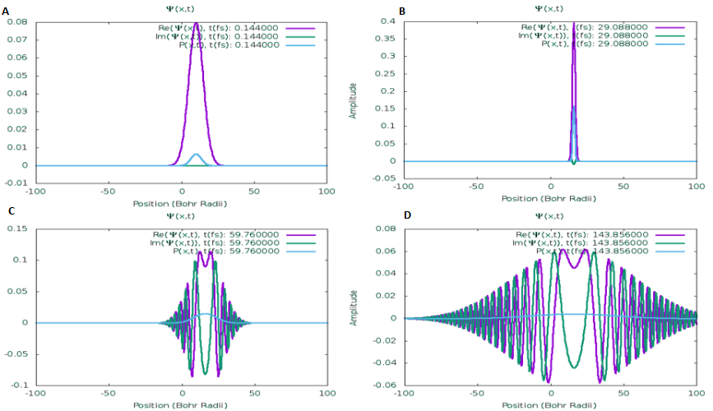

Figure 1. In B, the wave function has collapsed to a specific point giving us the position of our particle. In D, we can see the wave expand in both directions, which demonstrates the uncertainty of the momentum.

The importance of quantum measurement simulation is undeniable. Quantum simulators are much more useful and efficient at emulating much larger quantum systems than classical computers are able to. Since quantum simulators are quantum systems themselves, they provide the basis for analyzing and understanding a variety of different quantum related phenomena. They are typically best utilized in problems that are either intractable on classical computers or challenging to directly take on experimentally [3]. There are many different fields in which the applications of a quantum measurement simulator are recognizable. Some of these fields where they are highly utilized are in condensed-matter physics, high-energy physics, cosmology, and atomic physics [2]. Some of the areas that it tackles in condensed-matter physics include but are not limited to quantum phase transitions, Hubbard models, Spin models, Spin glasses, High Tc superconductivity, and disordered systems [3]. In High-energy physics, it is utilized in lattice gauge theories and Dirac particles. Some of the areas it deals with in cosmology include Hawking radiation, the Unruh effect and Universe expansion [3]. In Atomic physics it can be useful in problems related to Cavity QED and cooling [3]. In chemistry we can incorporate it into thermal rate calculations, molecular energies, and chemical reactions [3]. It is also highly utilized in solving problems related to the Schrödinger equation, quantum thermodynamics, and nonlinear interferometers [3].

Since the concept of a quantum measurement simulator is similar and highly influenced by the Stern-Gerlach experiment, it is necessary to recognize the applications for the Stern-Gerlach experiment as well. One of the important concepts that utilized a more sophisticated version of the experiment is the Rabi cycle, also called the Rabi flop. Isidor Rabi and some of his colleagues discovered the concept in the 1930’s, which showed that by using a varying magnetic field, it was possible to force the magnetic moment to change states. A few years later, they discovered that it was possible to induce state transitions by using a time varying field, known as RF fields (radio frequency fields). Basically, the Rabi cycle is the cyclic behavior of a two-level quantum system driven by an oscillatory field. A two level system has two levels, and if those levels are not degenerate, (not equal in energy for example), then the system becomes excited and absorbs a quantum of energy [9]. When an atom is illuminated by a coherent beam of photons, it will absorb the photons cyclically and then re-emit them by the process of stimulated emission. This is the process by which an incoming photon carrying a specific frequency interacts with an excited atomic electron, which ultimately causes it to drop to a lower energy level [10]. The Rabi cycle is highly utilized in MRI (Magnetic Resonance Imaging) equipment in hospitals and medical centers around the world.

Another important application of the Stern-Gerlach experiment was in the development of the Hydrogen Maser, which is till this day of the world’s best functioning atomic clocks. Masers in general are atomic clocks that have outstanding short-term stability. There are two types of hydrogen masers, ones that are classified as being active and ones that are considered passive. In the early sixties, Ramsey and Daniel Kleppner used a sort of Stern-Gerlach mechanism in order to produce a beam of polarized hydrogen as the source of energy for the hydrogen maser. Some of the components of the hydrogen maser are the hydrogen gas supply, a controllable leak for the gas into the high vacuum system, a gas discharge in order to produce atomic hydrogen, and a state selector which rejects atoms in the lower energy states and focuses the higher state ones into the storage bulb [7]. Basically what happens is a small storage bottle supplies molecular hydrogen into the gas discharge bulb [7]. From there, the molecular hydrogen is dissociated into atomic hydrogen. The atomic hydrogen then passes through a source collimator as well as a magnetic state selector which sorts the atoms based on different atomic state desirability [7]. Afterwards, the desired atoms will continue into the resonance cavity where they come across other radiating atoms and fall in step [7]. They start to in a way talk to one another, which produces echoes and “ringings” [5][7]. This back and forth communication produces a very highly coherent oscillation, which serves as the signal to which the crystal oscillator becomes phase-locked [7]. The hydrogen maser is a very sophisticated device with wide range imperative utilizations. Had it not been for the Stern-Gerlach experiment then it may possibly not exist today. Also, had it not been for the discovery of the ability to construct a quantum measurement simulator, many of the discoveries made in the biological, chemical, and physical world would still be a mystery. This world is filled with scientific mysteries waiting to be discovered and quantum simulators serve as a way to answer some of the questions that people once thought were impossible to answer. That is the beauty of quantum mechanics.

References

[1] Lloyd, S. Universal Quantum Simulators. *American Association for the Advancement of Science.* 1996. 273, 1073-1078.

[2]Georgescu, M., Ashhab, S. and Nori, F. Quantum Simulation. *Quantum Photonics.* 2014. 1- 41.

[3] Buluta, I. and Nori, F. Quantum simulators. *Science Review*. 2009. 326 (5949), 108-111.

[4] <http://www.quantum.umb.edu/Jacobs/QMT/QMT_Chapter1.pdf>

"Physicist Erwin Schrödinger's Google doodle marks quantum mechanics work". *[The Guardian](https://en.wikipedia.org/wiki/The_Guardian" \t "_blank)*. 13 August 2013.

Ushakov, N.G. (2001)*.*  "Density of a probability distribution." In Hazewinkel, Michiel,  *Encyclopedia of Mathematics,* Springer,  [ISBN](https://en.wikipedia.org/wiki/International_Standard_Book_Number" \t "_blank) 978-1-55608-010-4.

Hazewinkel, Michiel. (2001)."Runge-Kutta method.”  *Encyclopedia of Mathematics.* Springer,  ISBN 978-1-55608-010-4.

[5]Y. Kaluzny, P. Goy, M. Gross, J.M. Raimond, and S. Haroche. Observation of Self-Induced Rabi Oscillations in Two-Level Atoms Excited Inside a Resonant Cavity: The Ringing Regime of Superradiance. *American Physical Society*.1983. 51:13.

[6] D. Kleppner, H.C. Berg, S.B. Crampton, N.F. Ramsey, R.F.C. Vessot, H.E. Peters, and J. Vanier. Hydrogen-Maser Principles and Techniques. *American Physical Society*. 1965. 138:4A.

[7] <http://tycho.usno.navy.mil/maser.html>

[8] <http://quantummechanics.ucsd.edu/ph130a/130_notes/node34.html>

[9] <https://users.physics.ox.ac.uk/~smithb/website/coursenotes/qi/QILectureNotes4.pdf>

[10] <https://www.youtube.com/watch?v=YHmGNDMV1cY>